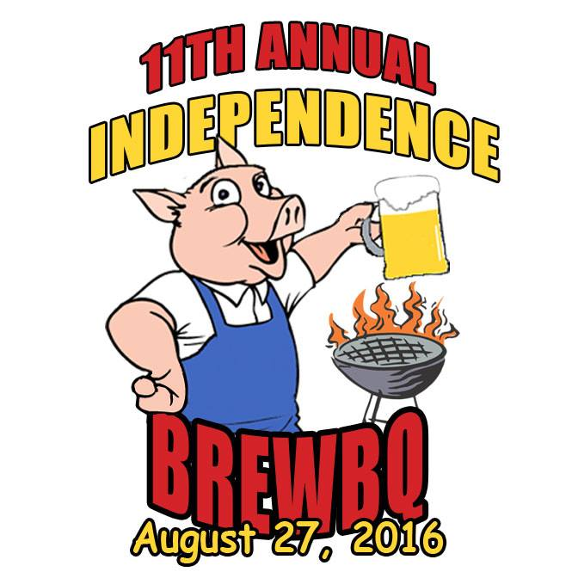
Sponsorship Request Form
11th Annual BrewBQ
August 27, 2016

Your sponsorship dollars will help us put the Independence BrewBQ on the top of the list for summer outdoor events. Please consider our charity partner, Independence Area Food Pantry when making your sponsorship level selection.
SPONSORSHIP LEVELS
Full Slab:  $1,000 | -3’ x 5’ Company Banner at Event*  - TV/Radio Spots*  -Logo on Marketing Materials**  -Website, Facebook, Twitter Promotion  -4 entries to Craft Brew Zone (w/Souvenir Glass)  -4 BrewBQ T-shirts
Half Slab:  $500 | -3’ x 5’ Company Banner at Event*  - Website, Facebook, Twitter Promotion  -Logo on T-Shirt**  -2 entries to Craft Brew Zone (w/Souvenir Glass)  -2 BrewBQ T-shirts
Pulled Pork:  $250 | -3’ x 5’ Company Banner at Event*  - Website, Facebook, Twitter Promotion  -Logo on T-Shirt**
Brisket: $100 | - Website, Facebook, Twitter Promotion
All sponsors will be announced throughout the event
* | All Banners & Radio Spots will be handled by the BrewBQ Committee.
** | Deadline July 7 for logo on marketing materials and T-Shirts

For more information, please contact:
Sara Sheeley
sara@brewbq.org

Company Name |  |  |  |  | Full Slab | $1,000
Contact |  |  |  |  | Half Slab | $ 500
Address |  |  |  |  | Pulled Pork | $ 250
Phone |  | e-mail |  |  | Brisket | $ 100
Please make your check payable to Independence BrewBQ.  Mail to PO Box 366, Independence, IA 50644  or contact Sara for pick up (sara@brewbq.org) |  |  | $

